Back-to-School
Carnival

All School Corporations and homeschoolers welcome!

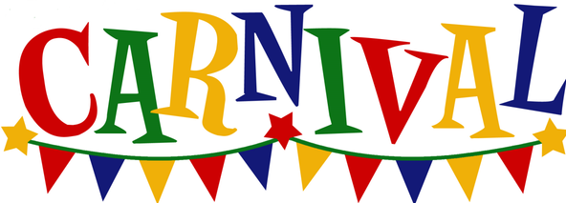
Tuesday August 1st from 5:30-7:30 PM
Please join us for a fun evening of food, carnival games, and
winning school supplies!
Event is totally free!

Held at:

First Baptist Church 409 S. Beach Dr. Monticello, IN

574-583-8247 – firstbaptistmonticello.com

